

Project Report - 01

Master of Computer Application – General Semester – I

Sub: Front-End Frameworks And Technologies

Topic: EV BIKES WEBSITE
By Name: Punith M
Reg no.: PROV/ASAC/MCA/7/25/082

Faculty Name: VEERA RAGHAV K

Faculty Signature: _______________

Department of Computer Application
Alliance University
Chandapura - Anekal Main Road, Anekal
Bengaluru - 562 106
Feb 2026

LIST OF TABLES

FIG NO | NAME OF TABLE | PG NO
1 | INTRODUCTION | 1
2 | INPUT CODE | 2-4
3 | OUTPUT CODE | 5
4 | CONCLUSION | 6

INTRODUCTION

Electric Vehicles (EV) are becoming an important solution to reduce pollution and fuel consumption. With the increasing demand for eco-friendly transportation, electric bikes are gaining popularity because they are energy efficient, cost effective, and environmentally friendly.
The EV Bikes Website is designed to provide users with information about different electric bikes, their specifications, prices, features, and availability. This website allows users to explore various EV bike models, compare features, and make better purchasing decisions.
The main objective of this project is to create a user-friendly platform where customers can easily browse electric bikes, view detailed information, and stay updated with the latest EV technology. The website also helps promote sustainable transportation and encourages people to adopt electric mobility.
This project is developed using modern web technologies to ensure a responsive, attractive, and easy-to-use interface for users.

INPUT CODE

<!DOCTYPE html>
<html lang="en">
<head>
<meta charset="UTF-8">
<title>EV Bikes</title>

<style>
body{
font-family: Arial, sans-serif;
margin:0;
background:#f0f7f3;
}

/* Navbar */
.navbar{
width:1000px;
margin:auto;
background:#59c251;
color:white;
display:flex;
align-items:center;
justify-content:space-between;
padding:12px;
}
.h2{
text-align: center;
color: rgb(182, 51, 51);
font-size: 36px;
margin-top: 20px;
}
.navbar ul{
list-style:none;
display:flex;
gap:18px;
}

.navbar a{
text-decoration:none;
color:rgb(212, 174, 211);
}

.navbar button{
padding:6px 10px;
}

/* Sections */
section{
width:1000px;
margin:20px auto;
background:rgba(81, 165, 105, 0.864);
padding:20px;
border-radius:8px;
text-align: center;
}

/* Table */
table{
width:100%;
border-collapse:collapse;
}

th, td{
border:1px solid #ccc;
padding:10px;
text-align:center;
}

/* Login Form */
input{
width:100%;
padding:8px;
margin:8px 0;
}

button{
text-align: center;
padding:10px;
}

/* Gallery */
.gallery{
display:grid;
grid-template-columns:repeat(4,1fr);
gap:10px;
}

.gallery img{
width:100%;
border-radius:6px;
}

/* Footer */
footer{
width:1000px;
margin:auto;
background:#0b3d2e;
color:white;
text-align:center;
padding:15px;
}
</style>
</head>

<body>

<!-- Navbar -->
<div class="navbar">
<h2>EV Bikes</h2>

<ul>
<li><a href="#">Home</a></li>
<li><a href="#">Menu</a></li>
<li><a href="#">Services</a></li>
<li><a href="#">Contact</a></li>
</ul>

<button>Search</button>
</div>

<!-- Video -->
<section>
<h2>EV Bike Introduction</h2>
<video width="100%" controls>
<source src="C:\Users\mppun\OneDrive\Desktop\FFT_PUNITH\BIKE.MP4" type="video/mp4">
</video>
</section>

<!-- About -->
<section>
<h2>About EV Bikes</h2>
<p>
Electric bikes (EV bikes) are eco-friendly vehicles powered by electricity
instead of petrol. They reduce pollution, save fuel costs, and are perfect
for modern smart transportation. Our EV bikes provide high performance,
long battery life, and stylish design for daily commuting.
</p>
</section>

<!-- Table -->
<section>
<h2>Our EV Bike Branches</h2>
<table>
<tr>
<th>Branch</th>
<th>City</th>
<th>Available Models</th>
</tr>

<tr>
<td>Main Showroom</td>
<td>Bangalore</td>
<td>Volt X, Eco Ride</td>
</tr>

<tr>
<td>Branch 2</td>
<td>Hyderabad</td>
<td>Power EV, Smart Ride</td>
</tr>

<tr>
<td>Branch 3</td>
<td>Chennai</td>
<td>Volt Pro, City EV</td>
</tr>
</table>
</section>

<!-- Login Form -->
<section>
<h2>Login</h2>
<form>
<input type="text" placeholder="Username" required>
<input type="email" placeholder="Email" required>
<input type="password" placeholder="Password" required>
<button type="submit">Login</button>
</form>
</section>

<!-- Gallery -->
<section>
<h2>EV Bike Gallery</h2>
<div class="gallery">
<img src="C:\Users\mppun\OneDrive\Desktop\FFT_PUNITH\PUNITH2.jpg">
<img src="C:\Users\mppun\OneDrive\Desktop\PUNITH 3.jpg">
<img src="C:\Users\mppun\OneDrive\Desktop\PUNITH 4.jpg">
<img src="C:\Users\mppun\OneDrive\Desktop\FFT_PUNITH\Ultraviolette-F77-Mach-2.jpg">
</div>
</section>

<!-- Footer -->
<footer>
<p>© 2026 EV Bikes | Green Future Transportation</p>
</footer>

</body>
</html>

OUTPUT CODE
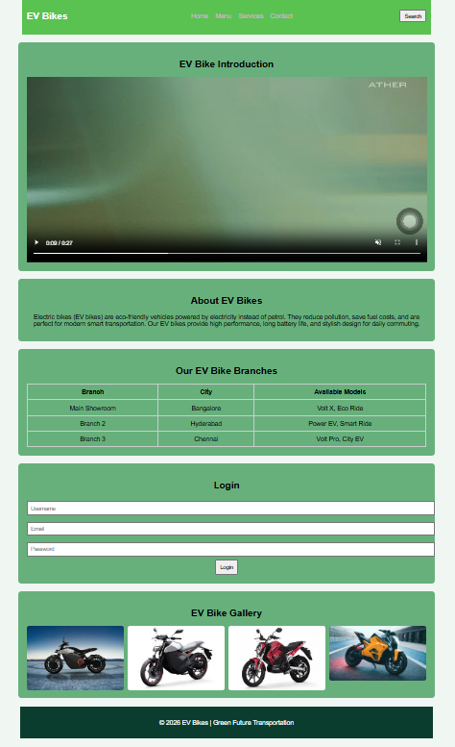

CONCLUSION
The EV Bikes Website project helps users easily explore and learn about different electric bikes available in the market. It provides important information such as bike features, specifications, prices, and benefits of using electric vehicles. The website makes it simple for users to compare bikes and understand the advantages of eco-friendly transportation.
This project also highlights the importance of electric mobility in reducing pollution and saving fuel. By creating a user-friendly and informative platform, the EV Bikes Website encourages people to adopt sustainable and environmentally friendly transportation options.
Overall, this project improves knowledge about EV technology and demonstrates how web development can be used to promote modern and green transportation solutions.

